DEFENCE QUESTIONS
Question No- 02
Mitigating Resume-Length and Keyword Bias

Raised Problem:
“How will you mathematically ensure that your AI shortlisting does not systematically disadvantage candidates who write shorter, more concise resumes compared to keyword-stuffed resumes?”
Illustrative example:
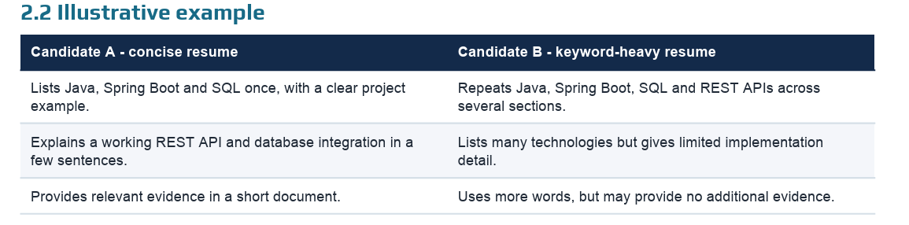
EXPECTED BEHAVIOUR
If both candidates provide equivalent evidence of equivalent qualifications, their scores should be approximately equal. Candidate B should not gain points merely by repeating a skill, and Candidate A should not lose points merely for being concise.

1. Background and existing approaches
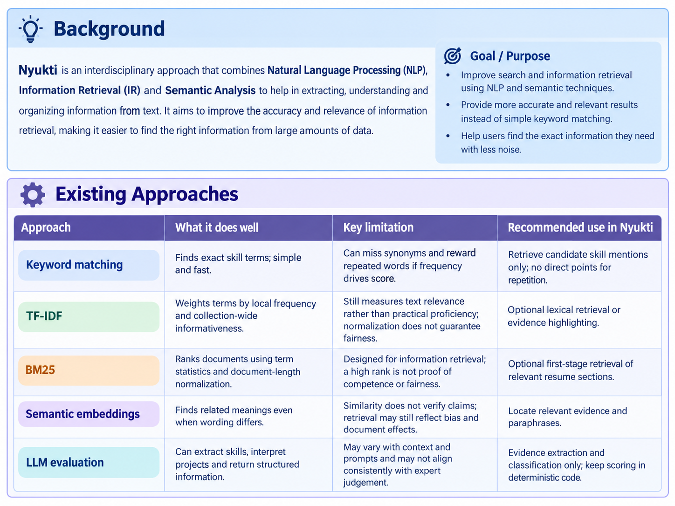

Why a hybrid system is preferable
- Lexical matching finds explicit skills (e.g., Java, SQL, Git).
- Semantic retrieval finds relevant descriptions with different wording.
- Evidence classification separates claims from projects and assessment results.
- Deterministic scoring applies consistent weights and score limits.
- Counterfactual tests reveal sensitivity to irrelevant changes.

DESIGN CHOICE
Use AI to locate and organize evidence; use fixed, inspectable rules to score it. Treat retrieval similarity as one signal, not the final hiring score.

2. Proposed Solution Architecture
The candidate pipeline produces an explainable recommendation; the separate validation pipeline tests score and ranking stability on controlled resume variants.
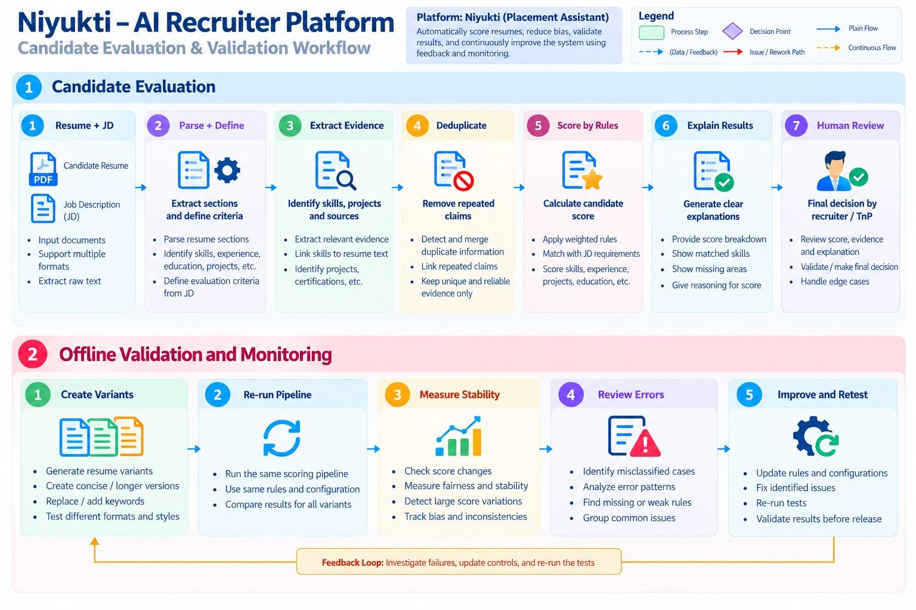

Our Approach
“NIYUKTI evaluates resumes against job requirements using a structured and fair scoring system. It extracts information from resumes and job descriptions, matches skills with supporting evidence, and assigns scores using fixed weights and predefined rules. Duplicate claims are counted only once to avoid inflated scores. The system also explains its recommendations, highlights missing information, and tests for bias to ensure that candidates with similar qualifications receive fair scores, regardless of resume length.”

Evidence traceability
Link every criterion score fail findings its resume excerpt, source location, evidence type, rubric level and verification status. The LLM returns structured data (e.g., JSON) but cannot change weights or invent evidence. Store assessments and reviewer overrides separately from resume claims.

3. Mathematical Mitigation Techniques
Use a fixed, job-specific rubric with bounded contributions. Cap keyword effects, deduplicate evidence and test robustness.

Fixed, job-specific weighted rubric
Illustrative rubric for a Java Backend Developer internship:
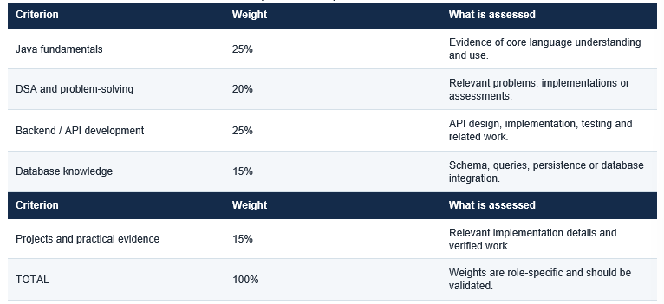
Score each job-description skill from 0–4 using the evidence location shown below. If the skill appears in more than one section, use the highest applicable score. The levels shown are illustrative.

Scoring rule: award only one score per skill, using the strongest supported section: Certifications (4) > Experience (3) > Projects (2) > general resume mention (1). If the skill is absent, score 0. Repeated mentions within or across sections do not add extra points.
W_i is the criterion weight (%) and r_i the evidence score (0–4); all weights sum to 100.
S = sum over i of [ W_i x (r_i / 4) ] where 0 <= S <= 100

Example: scores 4, 3, 2, 3, 4 with weights 25, 20, 25, 15, 15 produce 78.75/100. Once rubric scores are set, calculation is deterministic.
IMPORTANT LIMIT
A fixed formula prevents word count from entering the score directly, but it does not by itself stop a model from assigning higher evidence levels to verbose wording. Evidence extraction must also be tested and calibrated.

Evidence-based skill extraction
For each skill, record its name, source excerpt/location, evidence type, rubric level, uncertainty and verification status.
“Implemented a Sudoku solver using backtracking in Java” supports a project claim; “Skills: Java” is only a claim; an assessment shows performance on that test. No single item proves universal mastery.

Capped keyword contribution
Preferred rule: raw keyword frequency earns no direct points. Keywords may retrieve evidence, not prove skill. If retained in a legacy feature, cap the frequency signal:
f(k) = min(k / m, 1)

Here k is occurrence count and m the cap threshold. With m=2, counts 0, 1, 2, 5 and 10 yield 0, 0.5, 1, 1 and 1. Capping repetition does not prevent unsupported lists of different skills; evidence rules are still required.

Duplicate-evidence handling
- Extract evidence statements and source locations.
- Find exact duplicates and paraphrases of the same achievement.
- Link repeats to one underlying evidence item.
- Score unique evidence and enforce each criterion’s maximum.
- Count distinct achievements only where the rubric permits.

Robustness property
For qualification-preserving transformation T: S(R) approximately equals S(T(R))

R is the original resume; T(R) is a transformed version with the same job-relevant evidence. With identical extracted evidence and deterministic scoring, scores should match. Extraction errors may still cause variation, so test this property empirically.

4. Experimental Design and Evaluation Metrics
Validate observed behavior, not just the formula, by comparing the baseline and proposed pipeline on the same resumes and job descriptions.

Test dataset and controlled transformations
Start with at least 50 base resumes across three job descriptions, subject to consent, data quality and access. This is an engineering pilot, not a statistically powered guarantee; expand before making broad claims.

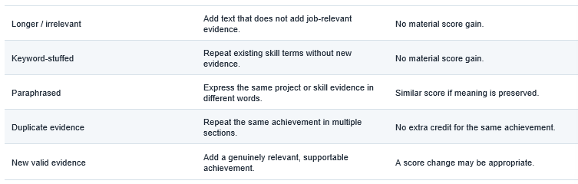
Check that transformations preserve qualifications. Keep rubric, model, prompts and scoring settings consistent across comparisons; repeat selected runs to estimate variability.

Metric A - Mean score sensitivity
MSS = (1 / N) x sum_i |S_i - S_i'|

Compare each original score S_i with transformed score S_i'. Lower mean absolute change indicates greater stability. Also report maximum change and results by transformation to expose outliers.

Metric B - Keyword-stuffing gain
KG = S(R_stuffed) - S(R_original)

Without new evidence, the desired gain is approximately zero. Report average and worst-case gain. A rise from 65 to 84 caused only by repeated keywords is a failure.

Metric C - Shortlist stability
J(A, B) = |A intersect B| / |A union B|

A is the original top-K shortlist and B the transformed shortlist. Jaccard=1 means identical shortlists. Inspect cutoff cases, where small score changes can alter selection.

Metric D - Qualification precision and recall
Precision = TP / (TP + FP) Recall = TP / (TP + FN)

TP = qualified candidates correctly shortlisted; FP = shortlisted candidates who do not meet the standard; FN = qualified candidates excluded. Use an agreed rubric and independent reviewers to establish reference labels; an AI score is not ground truth.

Metric E - Group-level error analysis
Where lawful and privacy-protective, compare selection and false-negative rates across relevant groups. Use group data for auditing, not individual scoring. Length robustness does not guarantee demographic fairness; investigate material disparities [1, 6].

Proposed initial pilot criteria
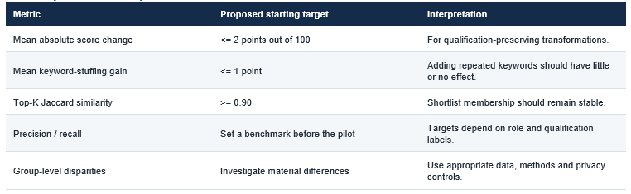
TARGETS ARE NOT RESULTS
These are proposed engineering thresholds, not universal fairness standards or measured Niyukti results. Final targets should be justified against baseline performance, error costs and validation evidence.

5. Limitations, Risks and Human Oversight

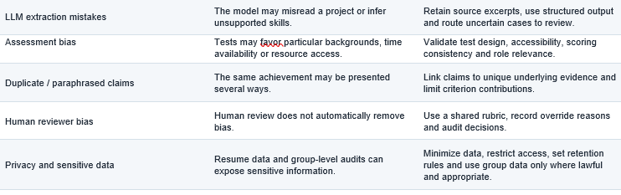

6. Conclusion and Expected Outcomes
Team Atom proposes fixed role-specific scoring, evidence extraction, duplicate control and controlled resume-variant testing to mitigate length and keyword bias.
Test the core claim: when qualifications are unchanged, irrelevant length or keyword changes should not materially alter scores or shortlist outcomes. Measure score sensitivity, keyword gain, top-K Jaccard similarity, precision, recall and group-level disparities.
The intended benefit is more consistent, explainable shortlisting. It remains a hypothesis until tested. Report results and limitations, and revise failures; the goal is to measure, reduce and monitor specific risks—not promise zero bias.

7. References
[1] Wilson, K. & Caliskan, A. (2024). “Gender, Race, and Intersectional Bias in Resume Screening via Language Model Retrieval.” AIES, 7(1), 1578–1590. https://doi.org/10.1609/aies.v7i1.31748. Reports demographic and document-length effects in resume retrieval.
[2] scikit-learn. “TfidfVectorizer” documentation. https://scikit-learn.org/stable/modules/generated/sklearn.feature_extraction.text.TfidfVectorizer.html. TF-IDF weighting and normalization options.
[3] Robertson, S. & Zaragoza, H. (2009). “The Probabilistic Relevance Framework: BM25 and Beyond.” Foundations and Trends in Information Retrieval, 3(4), 333–389. https://doi.org/10.1561/1500000019.
[4] Sentence Transformers. “Semantic Search” documentation. https://www.sbert.net/examples/sentence_transformer/applications/semantic-search/README.html.
[5] Varshney, A. & Ganuthula, V. R. (2025). “Signal or Noise? Evaluating Large Language Models in Resume Screening Across Contextual Variations and Human Expert Benchmarks.” arXiv:2507.08019. https://arxiv.org/abs/2507.08019. Preprint; interpret in light of its study design and status.
[6] NIST (2023). “Artificial Intelligence Risk Management Framework (AI RMF 1.0).” https://www.nist.gov/itl/ai-risk-management-framework. Guidance for managing AI trustworthiness and risk.

